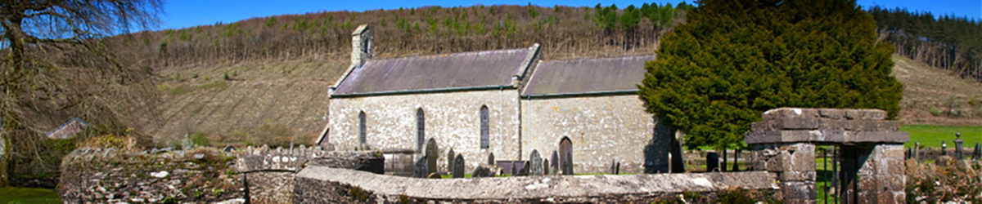

**CYNGOR CYMUNED LLANLLAWDDOG**

**LLANLLAWDDOG COMMUNITY COUNCIL**

75 Heol Pentre Felen, Llangyfelach, Abertawe / Swansea SA6 6DW

07968 033075

[ccllanllawddogcc@gmail.com](mailto:ccllanllawddogcc@gmail.com)

Cynhelir cyfarfod o Gyngor Cymuned Llanllawddog yn Neuadd yr Eglwys, Llanllawddog a thrwy Microsoft Teams ar **Nos Lun 3 Mawrth 2025 am 7.00yh.**

The meeting of Llanllawddog Community Council will be held at the Church Hall, Llanllawddog and via Microsoft Teams on **Monday 3 March 2025 at 7.00pm.**

Dyddiedig/Dated: 25/02/2025

**Nodyn:** **I gael mynediad i'r cyfarfod o bell trwy Microsoft Teams, cysylltwch â'r Clerc yn** [**ccllanllawddogcc@gmail.com**](mailto:ccllanllawddogcc@gmail.com) **dim hwyrach na 2 awr cyn cychwyn y cyfarfod ar gyfer y ddolen wahoddiad.**

**Note: To access the meeting remotely via Microsoft Teams, please contact the Clerk at** **[ccllanllawddogcc@gmail.com](mailto:ccllanllawddogcc@gmail.com) no later than 2 hours before the commencement of the meeting for the invitation link.**

**AGENDA**

1. Ymddiheuriadau am absenoldeb

Apologies for absence

2. Datganiadau o ddiddordeb

Declarations of interest

3. I gymeradwyo ac arwyddo cofnodion cyfarfod y Cyngor a gynhaliwyd ar 6 Ionawr 2025.

To approve and sign the minutes of the meeting of Council held on 6 January 2025.

4. I Dderbyn Cyflwyniad gan Ymddiriedolaeth Bywyd Gwyllt Vincent ar Ddichonoldeb Adfer Cathod Wyllt yng Nghymru

To Receive a Presentation from the Vincent Wildlife Trust on the Feasibility of Restoring Wildcats in Wales

5. Cronfa Gymunedol Fferm Wynt Brechfa

Brechfa Wind Farm Community Fund

6. Ardal Chwarae Fferm Cefn, Rhydargaeau

Cefn Farm Play Area, Rhydargaeau

7. I Dderbyn Adroddiad y Cynghorydd Sir

To Receive the Report of the County Councillor

8. Monitro’r gyllideb am y cyfnod yn diweddu 28 Chwefror 2025

Budget monitoring relative to the period ending 28 February 2025

9. Adnewyddu Yswiriant y Cyngor

Renewal of Council’s Insurance

10. Biliau i'w talu

Bills for payment

11. Diogelwch Priffordd ar yr A485

Road Safety on the A485

12. Cais am Dorri Ymylon yn Ddiweddarach

Request for Later Cut of Verges

13. Enwebu Cynrychiolydd Cyngor Cymuned ar Gorff Llywodraethol Ysgol Peniel

Nomination Of Community Council Representative to the Governing Body of Peniel School

14. Rhaglen Gwaith

Work Programme

15. Model Reoliadau Ariannol 2024

Model Financial Regulations 2024

16. Polisi Rheoli Risg

Risk Management Policy

17. Cais am Gymorth Ariannol

Application for Financial Assistance

18. Casglaid Sbwriel Cymunedol

Community Litter Pick

19. Derbyn gohebiaeth

To receive correspondence

20. Ceisiadau cynllunio

Planning applications

21. Adroddiadau o gyfarfodydd

Reports of meetings

22. Dyddiad y cyfarfod arferol nesaf – 12 Mai 2025

Date of next ordinary meeting – 12 May 2025

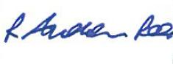

Andrew Rees

**Clerc Cyngor Cymuned Llanllawddog Community Council Clerk**

|  |
| --- |
| **Aelodau Cyngor Cymuned Llanllawddog Community Council Members** |
| Cynghorydd / Councillor Steven Mason (Cadeirydd / Chairperson) |
| Cynghorydd / Councillor Nia Bowen |
| Cynghorydd / Councillor Deborah Dean |
| Cynghorydd / Councillor Beth Gibbon |
| Cynghorydd / Councillor Havard Hughes |
| Cynghorydd / Councillor Philip Hughes |
| Cynghorydd / Councillor Darrell Lewis |
| Cynghorydd / Councillor Peter Williams |