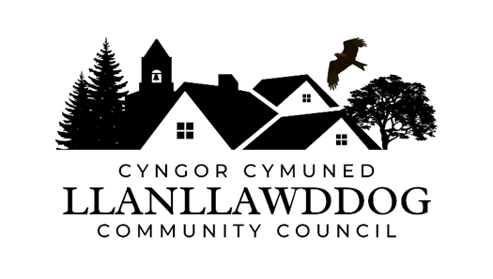
CYNGOR CYMUNED LLANLLAWDDOG
LLANLLAWDDOG COMMUNITY COUNCIL
75 Heol Pentre Felen, Llangyfelach, Abertawe / Swansea SA6 6DW
07968 033075
ccllanllawddogcc@gmail.com

Cynhelir cyfarfod o Gyngor Cymuned Llanllawddog yn Neuadd yr Eglwys, Llanllawddog a thrwy Microsoft Teams ar Nos Lun 11 Fai 2026 am 7.30yh.

The meeting of Llanllawddog Community Council will be held at the Church Hall, Llanllawddog and via Microsoft Teams on Monday 11 May 2026 at 7.30pm.

Dyddiedig/Dated: 05/05/2026

Nodyn: I gael mynediad i'r cyfarfod o bell trwy Microsoft Teams, cysylltwch â'r Clerc yn ccllanllawddogcc@gmail.com dim hwyrach na 2 awr cyn cychwyn y cyfarfod ar gyfer y ddolen wahoddiad.

Note: To access the meeting remotely via Microsoft Teams, please contact the Clerk at ccllanllawddogcc@gmail.com no later than 2 hours before the commencement of the meeting for the invitation link.

AGENDA

- Ymddiheuriadau am absenoldeb
Apologies for absence

2. Datganiadau o ddiddordeb
Declarations of interest

- Cyflwyniad Gan Bryony Whiffen, Ymgynghorydd Ynglyn a Datblygiad Cyfleusterau Cymunedol
Presentation by Bryony Whiffen, Consultant in Relation to the Development of Community Facilities

- Cais i Gefnogi Prosiect Strydoedd Trawsnewid Rhydargaeau
Request to Support Transition Streets Project Rhydargaeau

- Adroddiad y Cynghorydd Sir
Report of the County Councillor

6. Cynllun Gweithredu Bioamrywiaeth
Biodiversity Action Plan

7. Monitro’r gyllideb am y cyfnod yn diweddu 30 Ebrill 2026
Budget monitoring relative to the period ending 30 April 2026

8. Biliau i'w talu
Bills for payment

9. Ardal Chwarae Parc y Rhyd
Parc y Rhyd Play Area

10. Diogelwch Priffordd ar yr A485
Road Safety on the A485

11. Llwybrau Cyhoeddus
Public Footpaths

12. Adroddiad Blynyddol ar Gydnabyddiaeth Ariannol 2026-27
Annual Remuneration Report 2026-27

13. Rhaglen Gwaith
Work Programme

14. Ceisiadau am Cymorth Ariannol
Applications for Financial Assistance

15. Prosiect Diffibrilwyr Cymunedol
Community Defibrillator Project

16. Derbyn gohebiaeth
To receive correspondence

17. Ceisiadau cynllunio
Planning applications

18. Adroddiadau o gyfarfodydd
Reports of meetings

19. Dyddiad y cyfarfod arferol nesaf – 29 Mehefin 2026
Date of next ordinary meeting – 29 June 2026

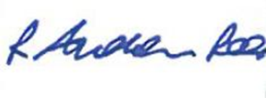
Andrew Rees Clerc Cyngor Cymuned Llanllawddog Community Council Clerk

Aelodau Cyngor Cymuned Llanllawddog Community Council Members
Cynghorydd / Councillor Steven Mason (Cadeirydd / Chairperson)
Cynghorydd / Councillor Nia Bowen
Cynghorydd / Councillor Deborah Dean
Cynghorydd / Councillor Beth Gibbon
Cynghorydd / Councillor Havard Hughes
Cynghorydd / Councillor Philip Hughes
Cynghorydd / Councillor Darrell Lewis
Cynghorydd / Councillor Peter Williams

