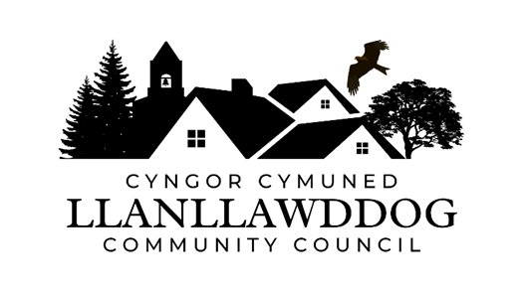
CYNGOR CYMUNED LLANLLAWDDOG
LLANLLAWDDOG COMMUNITY COUNCIL
75 Heol Pentre Felen, Llangyfelach, Abertawe / Swansea SA6 6DW
07968 033075
ccllanllawddogcc@gmail.com

Cynhelir cyfarfod o Gyngor Cymuned Llanllawddog yn Neuadd yr Eglwys, Llanllawddog a thrwy Microsoft Teams ar Nos Lun 2 Mawrth 2026 am 7.00yh.

The meeting of Llanllawddog Community Council will be held at the Church Hall, Llanllawddog and via Microsoft Teams on Monday 2 March 2026 at 7.00pm.

Dyddiedig/Dated: 24/02/2026

Nodyn: I gael mynediad i'r cyfarfod o bell trwy Microsoft Teams, cysylltwch â'r Clerc yn ccllanllawddogcc@gmail.com dim hwyrach na 2 awr cyn cychwyn y cyfarfod ar gyfer y ddolen wahoddiad.

Note: To access the meeting remotely via Microsoft Teams, please contact the Clerk at ccllanllawddogcc@gmail.com no later than 2 hours before the commencement of the meeting for the invitation link.

AGENDA

- Ymddiheuriadau am absenoldeb
Apologies for absence

2. Datganiadau o ddiddordeb
Declarations of interest

3. I gymeradwyo ac arwyddo cofnodion cyfarfod y Cyngor a gynhaliwyd ar 12 Ionawr 2026.
To approve and sign the minutes of the meeting of Council held on 12 January 2026.

4. Adroddiad y Cynghorydd Sir
Report of the County Councillor

5. Cynllun Gweithredu Bioamrywiaeth
Biodiversity Action Plan

6. Monitro’r gyllideb am y cyfnod yn diweddu 28 Chwefror 2026
Budget monitoring relative to the period ending 28 February 2026

7. Adnewyddu Yswiriant y Cyngor
Renewal of Council’s Insurance

8. Biliau i'w talu
Bills for payment

9. Datblygiad Cyfleusterau Cymunedol
Development of Community Facilities

10. Ardal Chwarae Parc y Rhyd
Parc y Rhyd Play Area

11. Diogelwch Priffordd ar yr A485
Road Safety on the A485

12. Llwybrau Cyhoeddus
Public Footpaths

13. Rhaglen Gwaith
Work Programme

14. Ceisiadau am Cymorth Ariannol
Applications for Financial Assistance

15. Prosiect Diffibrilwyr Cymunedol
Community Defibrillator Project

16. Derbyn gohebiaeth
To receive correspondence

17. Ceisiadau cynllunio
Planning applications

18. Adroddiadau o gyfarfodydd
Reports of meetings

19. Dyddiad y cyfarfod arferol nesaf – 11 Mai 2026
Date of next ordinary meeting – 11 May 2026

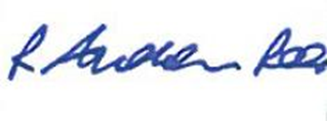
Andrew Rees
Clerc Cyngor Cymuned Llanllawddog Community Council Clerk
Aelodau Cyngor Cymuned Llanllawddog Community Council Members
Cynghorydd / Councillor Steven Mason (Cadeirydd / Chairperson)
Cynghorydd / Councillor Nia Bowen
Cynghorydd / Councillor Deborah Dean
Cynghorydd / Councillor Beth Gibbon
Cynghorydd / Councillor Havard Hughes
Cynghorydd / Councillor Philip Hughes
Cynghorydd / Councillor Darrell Lewis
Cynghorydd / Councillor Peter Williams

