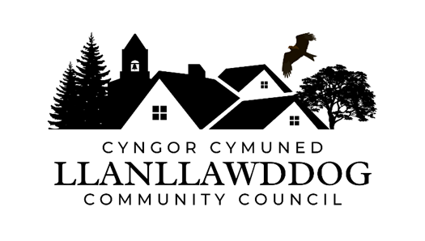

**CYNGOR CYMUNED LLANLLAWDDOG**

**LLANLLAWDDOG COMMUNITY COUNCIL**

75 Heol Pentre Felen, Llangyfelach, Abertawe / Swansea SA6 6DW

07968 033075

[ccllanllawddogcc@gmail.com](mailto:ccllanllawddogcc@gmail.com)

Cynhelir cyfarfod o Gyngor Cymuned Llanllawddog yn Neuadd yr Eglwys, Llanllawddog a thrwy Microsoft Teams ar **Nos Lun 30 Mehefin 2025 am 7.00yh.**

The meeting of Llanllawddog Community Council will be held at the Church Hall, Llanllawddog and via Microsoft Teams on **Monday 30 June 2025 at 7.00pm.**

Dyddiedig/Dated: 24/05/2025

**Nodyn:** **I gael mynediad i'r cyfarfod o bell trwy Microsoft Teams, cysylltwch â'r Clerc yn** [**ccllanllawddogcc@gmail.com**](mailto:ccllanllawddogcc@gmail.com) **dim hwyrach na 2 awr cyn cychwyn y cyfarfod ar gyfer y ddolen wahoddiad.**

**Note: To access the meeting remotely via Microsoft Teams, please contact the Clerk at** **[ccllanllawddogcc@gmail.com](mailto:ccllanllawddogcc@gmail.com) no later than 2 hours before the commencement of the meeting for the invitation link.**

**AGENDA**

1. Munud Ddistaw a Chyfnod o Ddyfalu

Minute’s Silence and Period of Reflection

1. Ymddiheuriadau am absenoldeb

Apologies for absence

3. Datganiadau o ddiddordeb

Declarations of interest

4. I gymeradwyo ac arwyddo cofnodion cyfarfod Blynyddol y Cyngor a gynhaliwyd ar 12 Mai 2025 a cofnodion cyfarfod y Cyngor a gynhaliwyd ar 12 Mai 2025.

To approve and sign the minutes of the Annual meeting of Council held on 12 May 2025 and the meeting of Council held on 12 May 2025.

5. Cronfa Gymunedol Fferm Wynt Brechfa

Brechfa Wind Farm Community Fund

6. Ardal Chwarae Parc y Rhyd

Parc y Rhyd Play Area

7. Monitro’r gyllideb am y cyfnod yn diweddu 30 Mehefin 2025

Budget monitoring relative to the period ending 30 June 2025

8. Datganiadau cyfrifyddu 2024-25 a Datganiad Llywodraethu Blynyddol

Accounting Statement 2024-25 and Annual Governance Statement

9. Paratoadau ar Gyfer Nadolig

Preparations for Christmas

10. Biliau i'w talu

Bills for payment

11. Diogelwch Priffordd ar yr A485

Road Safety on the A485

12. Rhaglen Gwaith

Work Programme

13. Cais am Gymorth Ariannol

Application for Financial Assistance

14. Llwybrau Troed ac Heolydd Ceffylau

Footpaths and Bridleways

15. Derbyn gohebiaeth

To receive correspondence

16. Ceisiadau cynllunio

Planning applications

17. Adroddiadau o gyfarfodydd

Reports of meetings

18. Dyddiad y cyfarfod arferol nesaf – 1 Medi 2025

Date of next ordinary meeting – 1 September 2025

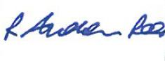

Andrew Rees

**Clerc Cyngor Cymuned Llanllawddog Community Council Clerk**

|  |
| --- |
| **Aelodau Cyngor Cymuned Llanllawddog Community Council Members** |
| Cynghorydd / Councillor Steven Mason (Cadeirydd / Chairperson) |
| Cynghorydd / Councillor Nia Bowen |
| Cynghorydd / Councillor Deborah Dean |
| Cynghorydd / Councillor Beth Gibbon |
| Cynghorydd / Councillor Havard Hughes |
| Cynghorydd / Councillor Philip Hughes |
| Cynghorydd / Councillor Darrell Lewis |
| Cynghorydd / Councillor Peter Williams |