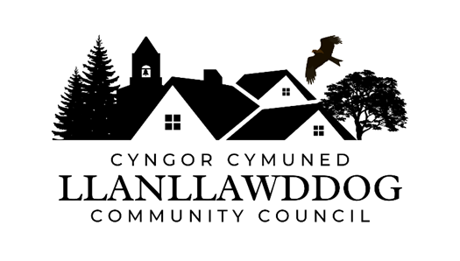

**CYNGOR CYMUNED LLANLLAWDDOG**

**LLANLLAWDDOG COMMUNITY COUNCIL**

75 Heol Pentre Felen, Llangyfelach, Abertawe / Swansea SA6 6DW

07968 033075

[ccllanllawddogcc@gmail.com](mailto:ccllanllawddogcc@gmail.com)

Cynhelir cyfarfod o Gyngor Cymuned Llanllawddog yn Neuadd yr Eglwys, Llanllawddog a thrwy Microsoft Teams ar **Nos Lun 1 Medi 2025 am 7.00yh.**

The meeting of Llanllawddog Community Council will be held at the Church Hall, Llanllawddog and via Microsoft Teams on **Monday 1 September June 2025 at 7.00pm.**

Dyddiedig/Dated: 26/08/2025

**Nodyn:** **I gael mynediad i'r cyfarfod o bell trwy Microsoft Teams, cysylltwch â'r Clerc yn** [**ccllanllawddogcc@gmail.com**](mailto:ccllanllawddogcc@gmail.com) **dim hwyrach na 2 awr cyn cychwyn y cyfarfod ar gyfer y ddolen wahoddiad.**

**Note: To access the meeting remotely via Microsoft Teams, please contact the Clerk at** **[ccllanllawddogcc@gmail.com](mailto:ccllanllawddogcc@gmail.com) no later than 2 hours before the commencement of the meeting for the invitation link.**

**AGENDA**

1. Ymddiheuriadau am absenoldeb

Apologies for absence

2. Datganiadau o ddiddordeb

Declarations of interest

3. I gymeradwyo ac arwyddo cofnodion cyfarfod y Cyngor a gynhaliwyd ar 30 Mehefin 2025 a chofnodion cyfarfod arbennig y Cyngor a gynhaliwyd ar 28 Gorffennaf 2025.

To approve and sign the minutes of the meeting of Council held on 20 June 2025 and the extraordinary meeting of Council held on 28 July 2025.

4. Cyflwyniad gan David Thomas Rheolwr Prosiect Trydan Gwyrdd Cymru ar Prosiect Ynni Adnewyddadwy Fferm Wynt Glyn Cothi

Presentation by David Thomas Project Manager on the Trydan Gwyrdd Cymru Glyn Cothi Wind Farm Renewable Energy Project

5. Adroddiad y Cynghorydd Sir

Report of the County Councillor

6. Ardal Chwarae Parc y Rhyd

Parc y Rhyd Play Area

7. Monitro’r gyllideb am y cyfnod yn diweddu 31 Awst 2025

Budget monitoring relative to the period ending 31 August 2025

8. Biliau i'w talu

Bills for payment

9. Paratoadau ar Gyfer Nadolig

Preparations for Christmas

10. Diogelwch Priffordd ar yr A485

Road Safety on the A485

11. Rhaglen Gwaith

Work Programme

12. Derbyn gohebiaeth

To receive correspondence

13. Ceisiadau cynllunio

Planning applications

14. Adroddiadau o gyfarfodydd

Reports of meetings

15. Dyddiad y cyfarfod arferol nesaf – 3 Tachwedd 2025

Date of next ordinary meeting – 3 November 2025

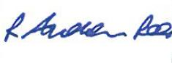

Andrew Rees

**Clerc Cyngor Cymuned Llanllawddog Community Council Clerk**

|  |
| --- |
| **Aelodau Cyngor Cymuned Llanllawddog Community Council Members** |
| Cynghorydd / Councillor Steven Mason (Cadeirydd / Chairperson) |
| Cynghorydd / Councillor Nia Bowen |
| Cynghorydd / Councillor Deborah Dean |
| Cynghorydd / Councillor Beth Gibbon |
| Cynghorydd / Councillor Havard Hughes |
| Cynghorydd / Councillor Philip Hughes |
| Cynghorydd / Councillor Darrell Lewis |
| Cynghorydd / Councillor Peter Williams |